Monday 8th November 2021

­Logic

Logic Gates

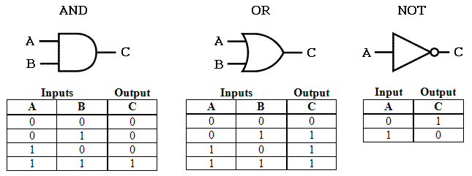

* And Gate – Outputs a 1 when both inputs are 1
* Or Gate – Outputs a 1 when either input is 1 (or both are 1)
* Not Gate – Outputs a 1 when the single input is 0 (inverts input)

Example

|  |  |  |  |  |  |
| --- | --- | --- | --- | --- | --- |
| A | B | C | A and B (D) | C or D | E |
| 1 | 1 | 1 | 1 | 1 | 0 |
| 1 | 0 | 0 | 1 | 1 | 0 |
| 0 | 1 | 0 | 1 | 1 | 0 |
| 0 | 0 | 0 | 1 | 1 | 0 |
| 1 | 1 | 1 | 0 | 1 | 0 |
| 1 | 0 | 0 | 0 | 0 | 1 |
| 0 | 1 | 0 | 0 | 0 | 1 |
| 0 | 0 | 0 | 0 | 0 | 1 |

Flowcharts

Start / Stop

Process

Input / Output

Decision